Energy transport processes inside stellar interiors
Introduction
In the cores of stars, nuclear fusion occurs due to the immense gravitational pressure, causing extremely high temperatures and energy. This energy can be transported to the star’s surface via two main mechanisms: radiative transport and convection. These processes can determine how a star maintains thermal equilibrium, model its evolution, lifespan and its fate.
Within this report, the diffusion approximation for radiative transport, the mixing length theory for convection, the Schwarzschild criterion for convective instability, the processes that occur in real stars and current research on convective overshooting, which may affect the lifespan and fate of stars, will be investigated.
Radiative transport
Radiative transport within stars is the process by which energy is carried outwards by photons produced in the core. Photons are produced by nuclear fusion when two atomic nuclei merge. This new, combined nucleus has less total mass than its original components, resulting in lost mass, which, is converted into energy, where a high-energy photon is produced.
When these photons are produced and travel outwards, they are constantly absorbed and re-emitted by matter. The process these photons undergo is called a random walk, as the re-emission direction is random. It is extremely slow due to the extreme density within stars, causing the photon to easily collide with matter and be re-emitted in a random direction.
The three main factors that control radiative transport are:
- The temperature gradient, causing the drive in energy flow from hot to cold – following the 2nd law of thermodynamics
- Opacity resisting the flow of photons
- Density affects how often the photons interact with each other
Opacity (k) is the measure of how strongly matter blocks incoming radiation (photons). A high opacity results in transport being inefficient as the photons get ‘stuck’, whereas a low opacity results in transport being efficient and fast and easily allows for radiative transport to occur. A high opacity can result in the trapping of heat, resulting in convection.
The diffusion approximation
The diffusion approximation is a simplification of the radiative transport process, where photon transport is treated as a diffusion process due to the frequent interactions of photons with matter. Resulting in the photons being treated like a diffusing liquid.
This simplification applies to the stellar interior, which is extremely dense, with high opacity, and has a very small mean free path. The mean free path is the average distance a particle takes between successive collisions and is given by the equation:
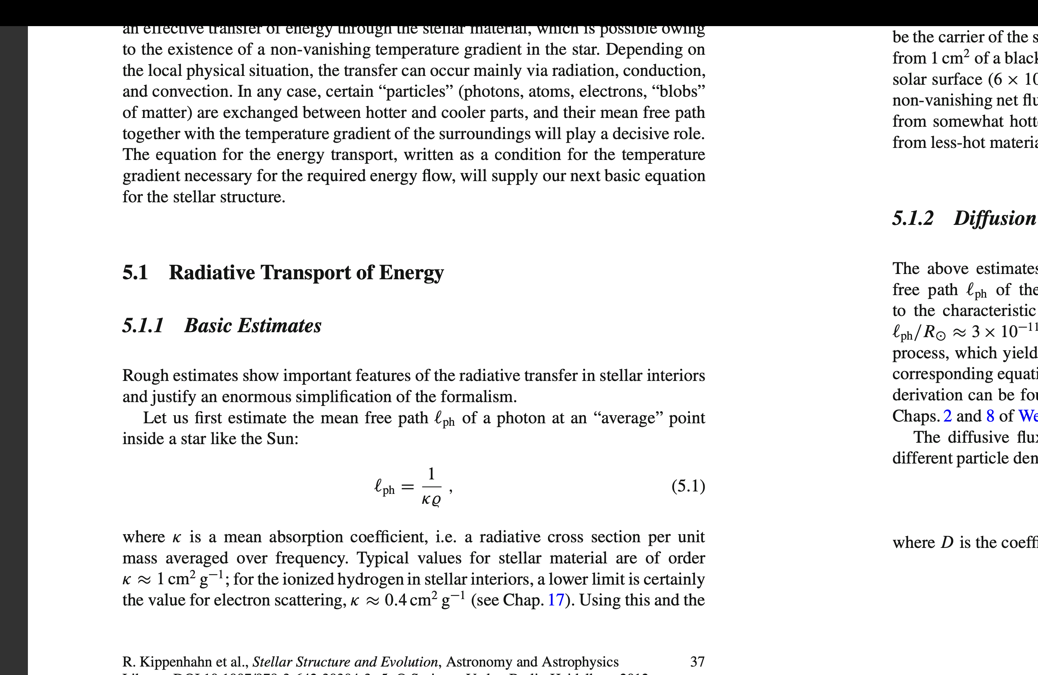
Where l_{ph} is the mean free path, k is the opacity, and p is the density.
The photons travel a tiny distance before being absorbed and re-emitted continuously within a highly opaque medium. This process can be thought of as heat spreading throughout a solid or ink spreading within water - approximated as a diffusion process, leading to the equation of radiative flux:
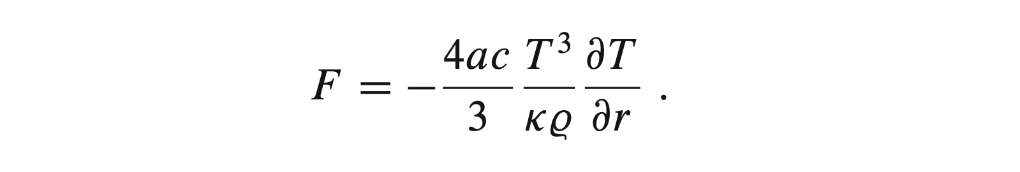
Convective transport
Convection in stars is the transportation of energy by a bulk movement of plasma upwards. This process occurs when a parcel of gas is heated due to nuclear fusion, causing the parcel to have greater kinetic energy, meaning particles are more spread out and have lower density.
If a parcel of gas has a lower density than its surroundings, it will rise due to buoyancy, as more dense areas above the parcel will be gravitationally attracted downwards, thus moving the hotter parcel upwards. The parcel has been adiabatically expanding and cooling throughout the movement upwards and will stop its upward movement once it reaches the point where it matches the temperatures and density of its surroundings. Without the lighter density of the parcel, gravity will halt its upward movement. This hot plasma rises, and cooler plasma sinks due to it being denser, creating a circulating and continuous convective current.
Mixing length theory
The Mixing Length Theory (MLT) is a simplified 1D model of convection used to describe the insides of stars. The theory assumes that parcels of hot plasma heated by nuclear fusion rise through denser, surrounding material over a characteristic distance called the mixing length before dissolving and transferring their excess heat into the surroundings.
The equation for the mixing length is:
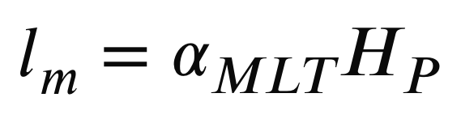
Where α_{MLT} is the mixing length parameter, and H_{P} is the pressure scale height.
Instability criterion
The Schwarzschild criterion
Parcels of gas can either be stable or unstable. If a displaced parcel is cooler and denser than its new surroundings, gravity will pull it back down, and the energy will continue to flow via radiation - a stable parcel. If the displaced parcel is warmer and less dense than its surroundings, then it will continue to rise, and energy will continue to be transported via convection - an unstable parcel.
The Schwarzschild criterion can be shown in terms of temperature gradient, where the equation for the temperature gradient is:
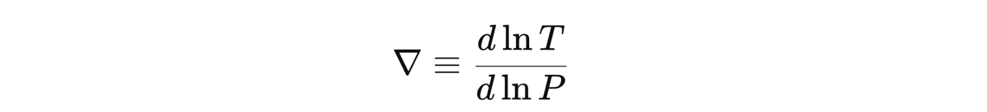
The Schwarzschild criterion states that a stellar region will be unstable if:
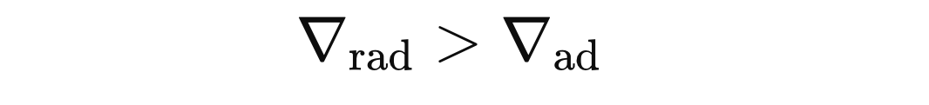
If this condition is met, then gas becomes convectively unstable as the parcel has a lower density and convection begins, causing the parcel to be buoyant and keep rising until the parcel reaches a stable region, where a displaced parcel becomes denser than its surroundings and sinks back to equilibrium. Opposingly, if:
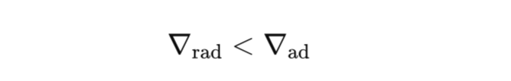
The region is stable, so heat and energy are transported entirely by radiation, and convection does not occur.
The radiative temperature equation:
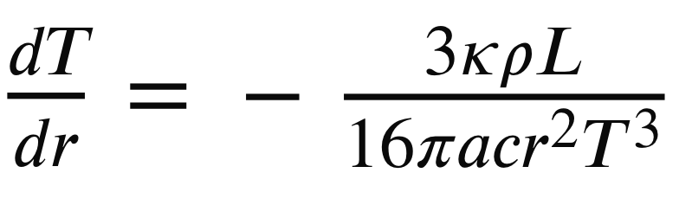
Being essential to determining if the transport it radiative or convective.
Real stars
The energy transport that occurs within a region of a star depends on its mass and its evolutionary stage.
A sun-like star in the main sequence:
For a star of around 1 solar mass, the core of the star is radiative:
These stars generate energy through the pp chain, resulting in a shallow temperature gradient within the core. Additionally, due to this reaction, the temperatures in the core are extremely high, producing a relatively low opacity as the atoms are fully ionised, resulting in radiation flowing through effectively.
In contrast, the outer envelopes of these stars are convective due to the temperature being cool enough for gas to absorb photons, reducing the efficiency of radiative transport. A steeper temperature gradient is required, however:
Causing the envelope to become unstable, and according to the Schwarzschild criterion, will result in convection.
A low-mass red dwarf:
In a very low mass red dwarf around 0.1-0.35 solar masses, the opacity is very high everywhere due to high density and low temperatures, and radiation is therefore unable to effectively transport energy so the star is fully convective. The radiative temperature gradient therefore becomes too steep and as a result:
Additionally, this explains the extremely long lifetimes as fresh hydrogen is constantly brought to the core of the star for nuclear fusion, allowing it to use its entire fuel supply before the star’s fate.
A massive star in the main sequence:
In stars exceeding 1.5 solar masses, energy is generated through the CNO cycle, resulting in extreme core temperatures. Resulting in an extremely large temperature gradient where:
According to the Schwarzschild criterion, the core becomes convectively unstable, resulting in a convective core.
The outer layers of the star are extremely hot and low in opacity due to high ionisation of stellar material. Radiation can therefore transport energy:
Resulting in the outer layers being radiative.
Current research
A major issue in energy transport research is convective overshooting. Most methods use the MLT, a 1D simplification of a fluid moving vertically. However, real stellar convection is a 3D process and uses a free parameter which sets how far a convective blob can travel before dissolving between convection zones.
The blob will often not stop at this boundary due to momentum, like a car braking. Causing parcels to cool and drag fresh hydrogen into the core, causing the size of the core to increase, and as there is more fuel in the core, the star’s lifetime increases.
A study made on the final fate of stars suggests that convective-core overshooting affects the fate of stars, causing more black holes as the core of the star is larger. Additionally, this study also talks about the missing red supergiant problem, where there are fewer red supergiants than expected. This study suggests that as overshooting changes the core, it could bypass the red supergiant phase and result in black holes.

Conclusion
Radiative and convective transport are the two dominant mechanisms for transferring energy within a star. Radiative transport occurs in stable regions, whereas convection occurs in areas with a steep temperature gradient.
The Schwarzschild criterion provides a condition that needs to be met for convection to occur, and if not, radiative transport will occur. The mixing length theory provides a simplification for modelling convection.
Understanding these energy processes is essential for being able to identify the stellar structure and its stellar evolution. Additionally, problems such as convective overshooting can result in the changing of stellar evolution.
References
Kippenhahn et al. – Stellar structure and evolution
https://www.aanda.org/articles/aa/full_html/2024/02/aa47434-23/aa47434-23.html - Convective core overshooting
Physics of convection inside stellar interiors – Ian Czekala YouTube video

